**The CosmoQuest Identity**

The goal of this Style Guide is to establish a clear, consistent and unique visual identity for CosmoQuest. Uniform graphic elements provide the framework for establishing a visual identity. In turn, designers can use this architecture to create materials that enhance public knowledge of CosmoQuest’s work.

## Basic Elements

##### The CosmoQuest Logo

The CosmoQuest logo is the primary logo for external communications material. The organization’s policies regarding logo usage are designed to ensure that the public recognition of the CosmoQuest logo is not diluted by other CosmoQuest identities. The logo must be included on all organization publications, displays, visual communications and markings. Designed in 2011, the CosmoQuest logo contains the following elements. Note that in the examples below the logo is on black for illustrative purposes only.



The CosmoQuest logo should be reproduced only from original reproduction proofs, transparencies, or electronic files that can be obtained from the CosmoQuest website.

The logo cannot be used in a sentence or congured with other symbols.

The logo cannot be placed at an angle.

**PIECES OF EIGHT FONT**

**DASHED LINE X**

Any logo adaptations needed to meet the printing

requirements of other formats (e.g., silkscreening, embossing, etc.) must be pre-approved by CosmoQuest.

## Basic Elements

##### The CosmoQuest X Logo

The X logo color should always remain CosmoQuest burgundy.

The X logo can also be used as a standard logo once the CosmoQuest logo has been introduced in the publication.

The X logo should not be rotated from its 27 degree angle.

**27° ANGLE**

## Basic Elements

##### Minimum Size

Always use the logo so that it is properly proportioned to the size of the page or panel to which it is being applied. The minimum size for the reproduction of the CosmoQuest logo is 1.5 inchs in length, with the exception of business cards and approved promotional items. For

on-screen applications, do not reduce the size below 100 pixels in width.

The X logo should be used when the CosmoQuest logos width is lesser than one and a half inches.



**1.5”**

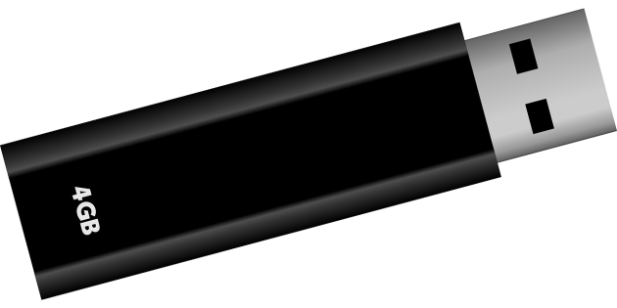



If a smaller insignia is required, permission must be granted from CosmoQuest, or the X logo must be used in the CosmoQuest logos place. The minimum size of the X logo is 5/8 of an inch.

**5/8”**

## Basic Elements

##### The CosmoQuest Logo Protected Space

The logo protected space refers to the clear space surrounding the logo in its entirety. This clear space ensures the unobstructed and visible placement of the CosmoQuest and X logos. The minimum width for the protected area is 1/4 of an inch around the logo.

No additional text may be placed within the protected area surrounding the CosmoQuest logo or X logo.

The logos should always be placed on a black, dark gray, or white background. No other colors should be used.

**1/4”**

**1/4”**

## Basic Elements

##### Color Variations: Print

The CosmoQuest logo has two variations: a full-color logo with white text and a full-color logo with black text. The X logo should only be used in burgundy. Select the most appropriate of the variations of the logo based on production requirements, media qualities, and visibility and proper usage. The following color codes should be used when the logo is being used in printed materials.



**BURGUNDY SPOT: Pantone 7628 C TAN SPOT: Pantone 7505 C**



**BLACK: C0 M0 Y0 K100**



**BURGUNDY PROCESS COLOR: C24 M95 Y92 K19 TAN PROCESS COLOR: C40 M56 Y78 K25**

## Basic Elements

##### Color Variations: Screen

The CosmoQuest logo has two variations: a full-color logo with white text and a full-color logo with black text. The X logo should only be used in burgundy. Select the most appropriate of the variations of the logo based on production requirements, media qualities, and visibility and proper usage. The following color codes should be used when the logo is being used for web or screen purposes.



**BURGUNDY SCREEN: R163 G42 B41 TAN SCREEN: R131 G96 B63**



**SCREEN: R0 G0 B0**



**BURGUNDY WEB: #A32A29 TAN WEB: #83603F**

## Basic Elements

##### Primary Color

Color plays a significant role in representing the CosmoQuest brand. Use CosmoQuest Red (Pantone 7628 C) on all corporate-wide communications. When consistently used over time, this color will become directly associated with the CosmoQuest brand. Only specific tints of this color, which have been listed below, have been approved for use.

**CosmoQuest Red 7628 C**

**80% 60% 40% 20%**

**100%**

###### (Existing color palette. The following pages are changes made based on Cia’s notes and observations.

**Process C18, M100, Y87, K8 RGB R188, G33, B50 #BC2132**

|  |
| --- |
|  |
|  |
|  |
|  |
|  |
|  |
|  |
|  |
|  |
|  |

**Process C0, M80, Y86, K0 RGB R240, G91, B54 #F05B36**

**Process C5, M20, Y83, K0 RGB R243, G199, B73 #F3C749**

**Process C85, M20, Y100, K7 RGB R26, G140, B68 #1A8C44**

**Process C84, M32, Y50, K8 RGB R25, G128, B127 #19807F**

**Process C86, M80, Y0, K0 RGB R66, G79, B162 #424FA2**

**Process C69, M86, Y0, K0 RGB R110, G71, B156 #6E479C**

**Process C37, M86, Y35, K7 RGB R159, G68, B110 #9F446E**

**Process C45, M38, Y38, K2 RGB R145, G145, B144 #919190**

**Process C0, M2, Y8, K0 RGB R255, G248, B233 #FFF8E9**

**Process C23, M100, Y89, K16 RGB R168, G30, B45 #A81E2D**

**Process C11, M82, Y92, K2 RGB R215, G83, B48 #D75330**

|  |
| --- |
|  |
|  |
|  |
|  |
|  |
|  |
|  |
|  |
|  |
|  |

**Process C16, M27, Y88, K0 RGB R218, G179, B66 #DAB342**

**Process C87, M26, Y100, K14 RGB R21, G125, B63 #157D3F**

**Process C86, M37, Y53, K15 RGB R24, G115, B114 #187372**

**Process C92, M87, Y0, K0 RGB R56, G68, B156 #38449C**

**Process C75, M89, Y9, K1 RGB R98, G63, B140 #623F8C**

**Process C41, M87, Y40, K15 RGB R143, G61, B99 #8F3D63**

**Process C51, M42, Y42, K7 RGB R130, G131, B131 #828383**

**Process C9, M9, Y17, K0 RGB R229, G223, B208 #E5DFD0**

**Process C13, M65, Y42, K0 RGB R216, G119, B123 #D8777B**

**Process C0, M47, Y47, K0 RGB R246, G155, B127 #F69B7F**

|  |
| --- |
|  |
|  |
|  |
|  |
|  |
|  |
|  |
|  |
|  |
|  |

**Process C3, M13, Y55, K0 RGB R247, G217, B136 #F7D988**

**Process C60, M7, Y72, K0 RGB R112, G182, B115 #70B673**

**Process C56, M15, Y36, K0 RGB R116, G176, B168 #74B0A8**

**Process C48, M43, Y0, K0 RGB R137, G141, B197 #898DC5**

**Process C36, M46, Y4, K0 RGB R167, G141, B187 #A78DBB**

**Process C23, M51, Y24, K0 RGB R197, G139, B158 #C58B9E**

**Process C27, M22, Y26, K0 RGB R189, G186, B179 #BDBAB3**

**Process C0, M2, Y8, K0 RGB R255, G248, B233 #FFF8E9**

## Basic Elements

##### Color Palette Specifications

The following color codes have been approved for use when creating graphics, publication material, or screen material for CosmoQuest. No modifications to these colors are permitted.

|  |  |  |  |  |
| --- | --- | --- | --- | --- |
|  | **Pantone (spot)** | **CMYK (print)** | **RBG (screen)** | **Hexadecimal (web)** |
|  |  |  |  |
|  | 7628 C | C24 M95 Y92 K19 | R163 G42 B41 | #A32A29 |
|  |  |  |  |  |
|  |  |  |  |  |
|  | 7505 C | C40 M56 Y78 K25 | R131 G96 B63 | #83603F |
|  |  |  |  |  |
|  |  |  |  |  |
|  | 300 C | C100 M62 Y7 K0 | R0 G92 B185 | #005CB9 |
|  |  |  |  |  |
|  |  |  |  |  |
|  | 186 C | C12 M100 Y91 K3 | R207 G10 B44 | #CF0A2C |
|  |  |  |  |  |
|  |  |  |  |  |
|  | BLACK 6 C | C81 M71 Y59 K75 | R17 G24 B32 | #111820 |
|  |  |  |  |  |
|  |  |  |  |  |
|  | 7527 C | C15 M13 Y21 K0 | R216 G210 B196 | #D8D2C4 |

## Basic Elements

##### Color Palette Specifications

Below are examples of the different levels of opacity of the CosmoQuest color palette. No other levels of opacity may be used when creating graphics, publication material, or screen material for CosmoQuest.

**100% 80% 60% 40% 20%**

## Basic Elements

##### Portal Address

The CosmoQuest portal address must be used on all CosmoQuest communication material except certificates. The location of the portal address should reflect its position as an essential component of the overall visual language created by the communications material.

**BRAND STYLE GUIDE**

[**www.cosmoquest.org**](http://www.cosmoquest.org/)

[**www.cosmoquest.org**](http://www.cosmoquest.org/)

The portal address must appear as follows: [www.cosmoquest.org](http://www.cosmoquest.org/)

The portal address may appear on either the front or back cover of a publication. Refer to the specific application for placement location. The only mandatory placement occurs when it is used with a center or program address on the back cover of a multipage publication (see page 22).

No Web addresses other than the portal can appear on a single-page publication or the front cover of a multipage pub- lication unless it is part of the publication’s title or in the body copy.

The portal address must remain separate from the identifier configuration and any other copy.

Example of portal placement.

## Basic Elements

##### Sans Serif Typeface

The Helvetica Neue type family is the approved CosmoQuest sans serif typeface. The typeface is available in many weights and styles that are essential to create distinction across all communications. Type cannot be placed over a product or logo. Prefered color usage of text is black or dark grey on a white or light background or white type on a dark grey or black background.

Additional fonts:

When creating educational material for middle-school or younger students,

audience-specific fonts may be

ABCdef

**Helvetica Neue Regular**

ABCdef

**Helvetica Neue Medium**

*ABCdef*

**Helvetica Neue Italic**

*ABCdef*

**Helvetica Neue Medium Italic**

used for both the headlines and the body text. Below are the approved fonts:

**ABCdef**

**Helvetica Neue Bold**

**ABCdef**

**Helvetica Neue Condensed Bold**

***ABCdef***

**Helvetica Neue Bold Italic**

**ABCdef**

**Helvetica Neue Condensed Black**

Daniel Regular

**A**Dani**B**el Bol**C**d

ABCd

ef

### def

#### ABCdef

**Helvetica Neue Thin**

ABCdef

**Helvetica Neue Light**

ABCdef

**Helvetica Neue UltraLight**

*ABCdef*

**Helvetica Neue Thin Italic**

*ABCdef*

**Helvetica Neue Light Italic**

*ABCdef*

**Helvetica Neue UltraLight Italic**

Daniel Black

*A*Talk*B*ing *C*to*d*th*e*e*f*Moon

**ABCdef**

Stencil STD

**ABCdef**

Arial may be used when Helvetica Neue is not available.

#### ABCdef

Arial

## Basic Elements

##### Serif Typeface

Garamond has been selected as CosmoQuest’s serif typeface, as it compliments Helvetica Neue with a more classical look-and-feel. Garamond is to be used sparingly, and never for large areas of body text on screen or web. The predominant typeface should always be Helvetica Neue.

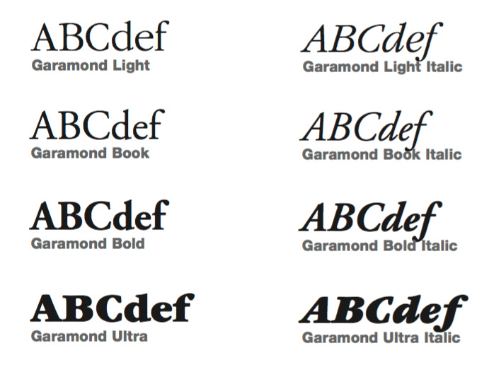

Times New Roman may be used when Garamond is not available.

ABCdef

Times New Roman

## Basic Elements

##### Headlines: Vertical Type

As another element of the CosmoQuest style, vertical layouts of short, primary headlines are encouraged on single-page publications and the front covers of multipage publications. A single line is the only allowable format; longer

headlines should be horizontal.

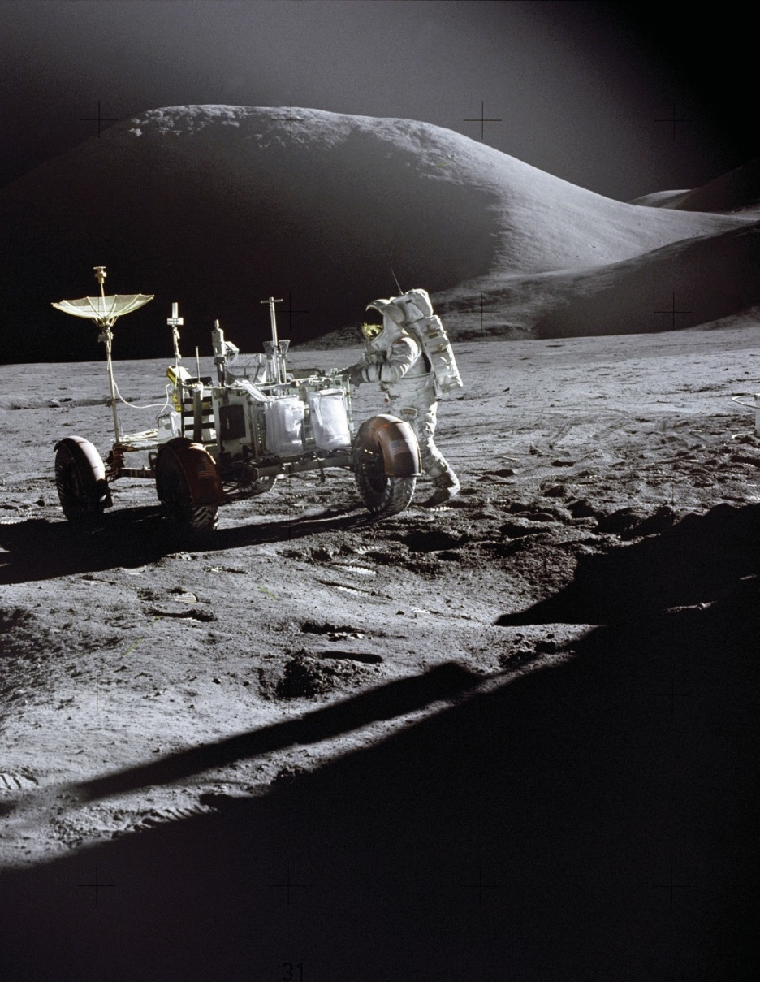

Align the vertical text so that the x-height of the letters is centered against the right of the CosmoQuest wordmark.

Vertical text must be placed on the right side of the publication. A vertical headline may not be more than one line of text, and the text must read upward.

Vertical type may not violate the identifer configuration’s protected space.

Vertical type must appear in Helvetica Neue Bold or, if unavailable, Arial Bold.

[**www.cosmoquest.org**](http://www.cosmoquest.org/)

## Basic Elements

##### Division Lines

Publication Style

**Single-Page Publications: Fliers and Posters**

Fliers and posters must incorporate all of the communication elements according to the placement standards. The preferred location of the portal address is the lower left-hand corner. No Web address other than that of the portal can appear unless it is part of the publication’s title or other body text.



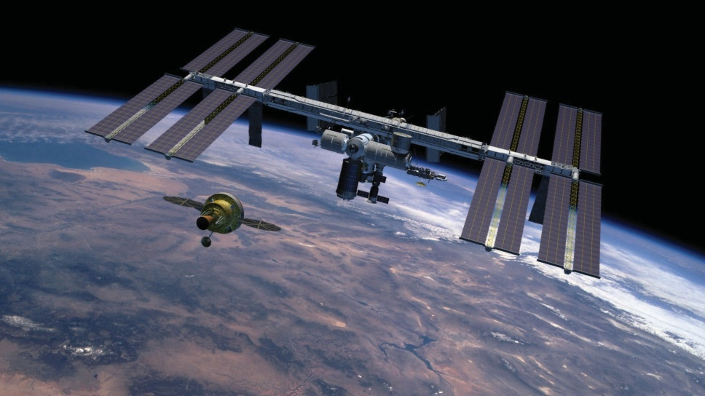

[**www.cosmoquest.org**](http://www.cosmoquest.org/)



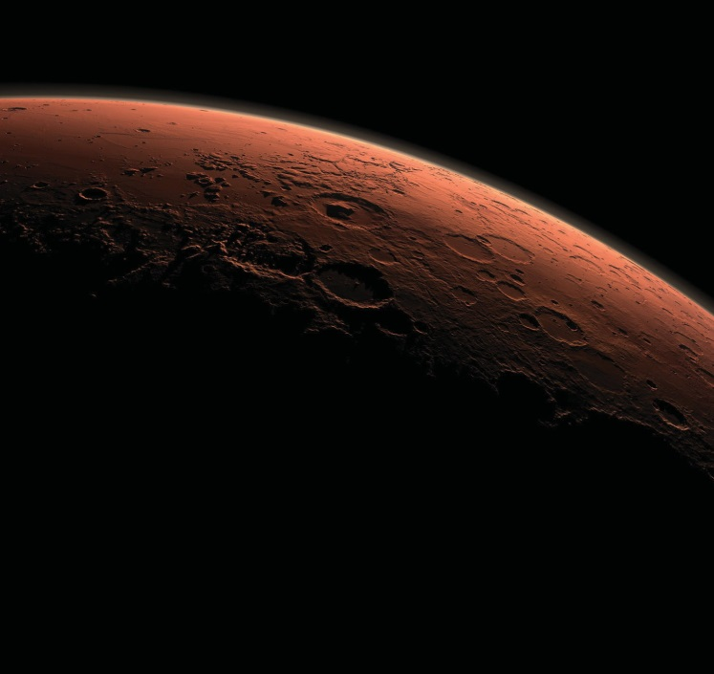

**Become a Mars Mapper today.**

[**www.cosmoquest.org**](http://www.cosmoquest.org/)

## Publication Style

##### Single-Page Publications: Table Signs

CosmoQuest table signs should adhere to either a standard letter size of be presented as a four inch by six inch table tent. If other dimensions are desired, permission must be granted from CosmoQuest. Unlike fliers or posters, the CosmoQuest portal address does not need to go on table signs.

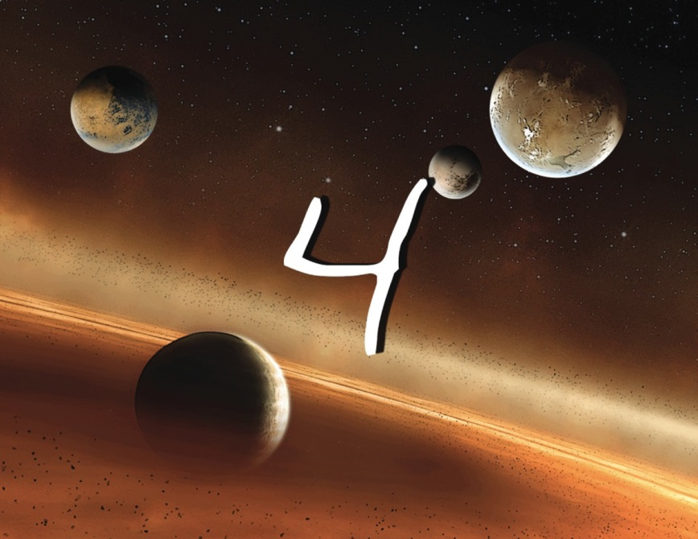

**Example of a letter size table card design**

## Publication Style

##### Multipage Publications: Front and Back Cover

The CosmoQuest logo must appear on the front cover of multipage publications.

Center and program names cannot appear on the front cover unless they are part of the publication’s title. Center names and physical and Web addresses may appear on the back cover.

The preferred location of the portal address is on the back cover. No Web address other than that of the portal can appear on the front cover unless it is part of the publication’s title. If both the portal and center or program Web addresses are used on the back cover, they must be configured per the example below.

The publication number must be placed in the lowermost left-hand corner of the back cover.

Educational Products:

In addition to the usual branding elements, educational products must carry a box identifying the intended users and grade levels.

The box may appear in either of the lower corners of the front cover. (See below for an

example showing the box in the lower right-hand corner.)



[**www.cosmoquest.org**](http://www.cosmoquest.org/)

|  |  |
| --- | --- |
| Educational Product | |
| Educators & Students | Grades 9-12 |

**Front cover Back cover with portal only Front cover**

## Publication Style

##### Multipage Publications: Newsletters and Magazines

The format and layout of newsletters and magazines should be designed as part of the overall communication goal of the item with both the subject matter and audience in mind. There are no grid layout specifications for the inside pages of a multipage publication. The only specification is the placement of the elements per this guide.

|  |  |  |  |
| --- | --- | --- | --- |
|  | |  | |
|  |  |  |  |
|  | |  | |

**Examples of interior page formats**

## Publication Style

##### Multipage Publications: Brochures and Invitations

Just like with other publications, there are no grid or layout specifications for the inside pages of brochures and invitations. However, the placement of vertical text and use of image must comply to the CosmoQuest style guidelines.

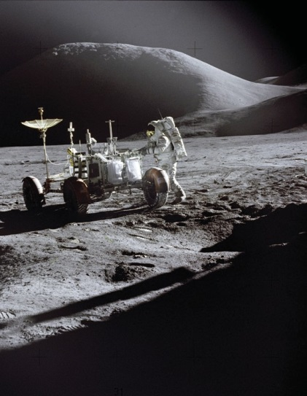











[**www.cosmoquest.org**](http://www.cosmoquest.org/)

**Example of lettersize cover design**

**Example of lettersize layout**



**Example of a custom-size cover design Example of a custom-size layout**

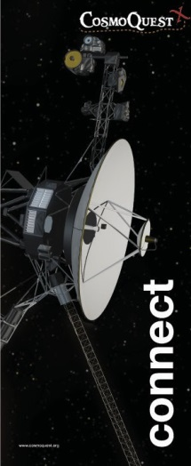

**Example of trifold brochure cover design**

**Examples of a trifold brochure layout**

## Electronic Media

##### Packaging

CD/DVD jewel case covers or videotape covers with both a front and back must conform to the cover standards for a multipage publication. If the case cover only has a printed font, then it must conform to the standards for a

single-page publication.

CD/DVD labels must use the CosmoQuest logo and the portal address. The logo must also appear on the spine.

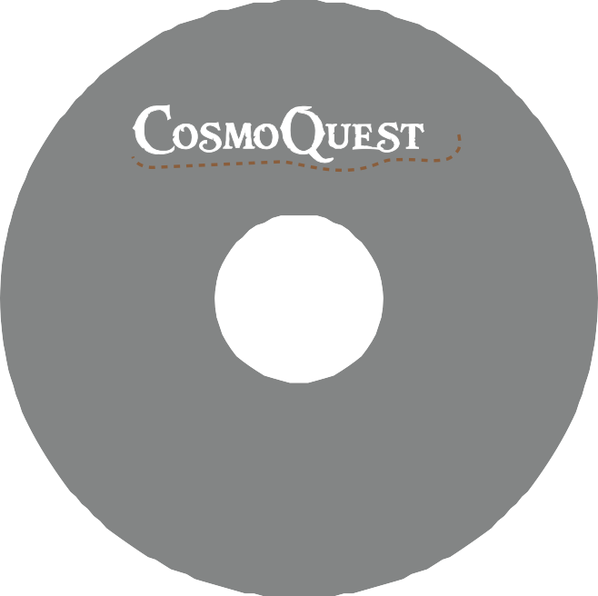

[**www.cosmoquest.org**](http://www.cosmoquest.org/)

**CD/DVD Label**



[**www.cosmoquest.org**](http://www.cosmoquest.org/)

**Jewel Case**

## Electronic Media

##### Electronic Slide Presentation Template

Electronic slide presentations are an important component of CosmoQuest’s communication strategy. Therefore, it is encouraged that all presentations incorporate the elements correctly and consistently.

When placing the CosmoQuest elements, think of an electronic slide presentation as a multipage publication with the first slide as the front cover, the last slide as the back cover, and the slides in between as the inside pages. However, the logo may be centered on the last slide as a sign off. A template can be provided from CosmoQuest upon inquiry.

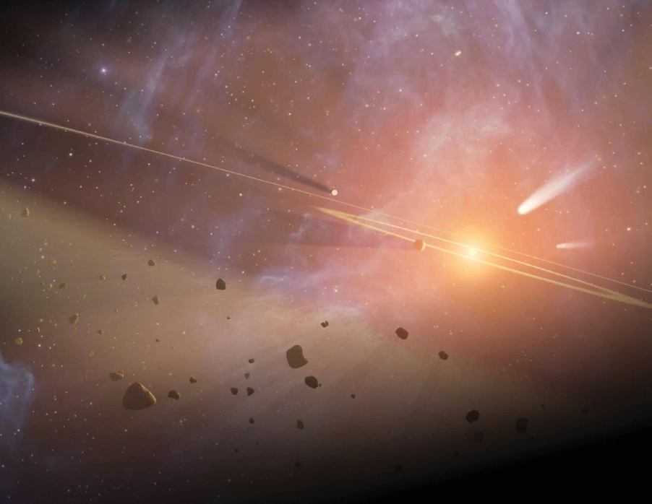





[**www.cosmoquest.org**](http://www.cosmoquest.org/)

**Example of a presentation first page design**



*Learning through Guided Inquiry & Authentic Investigations*

**funding by NASA, CAN, Patreon**

**Example of a presentation interior page design**

## Logos

##### Co-Sponsor Logos

Logos of co-funding partners may be used in CosmoQuest communications material, commercial merchandise, or hardware if they have advance approval from CosmoQuest.

Communications material developed with co-sponsors is not considered an exclusive CosmoQuest publication. Therefore, the guidelines for the CosmoQuest logo configuration do not apply.

When creating a grouping for a CosmoQuest publication, the CosmoQuest logo must be the first logo to appear. The logos must be of the same height so that they carry the same visual weight.



**Examples of acceptable**

**co-sponsor logo groupings**

## Stationery

##### Business Cards

Two variations on the CosmoQuest buisness card are available for use. Both designs must abide by the style guide standards with color and logo protected space. Personal information on the back is subject to change per user.



**John J. Doe**

Official Job Title Office or Division

phone email

cosmoquest.org



**John J. Doe**

Official Job Title Office or Division

phone email

cosmoquest.org

## Stationery

##### Letterheads

The Logo

**On Light or Medium Color Backgrounds**





**Choose background colors in which the vector CosmoQuest logo are clearly visible against the background.**

## The Logo

##### On Dark or Black Color Backgrounds





**Choose background colors in which the vector CosmoQuest logo are clearly visible against the background.**

## The Logo

##### Violations





**Never delete elements of the logo. Never add elements around the logo.**





**Never distort the logo. Never change the original colors.**



**Never add other colors to any elements of the logo. Never add a glow to the logo.**



PODCASTS

**Never rearrange any elements of the logo. Never incorporate other text into the logo**